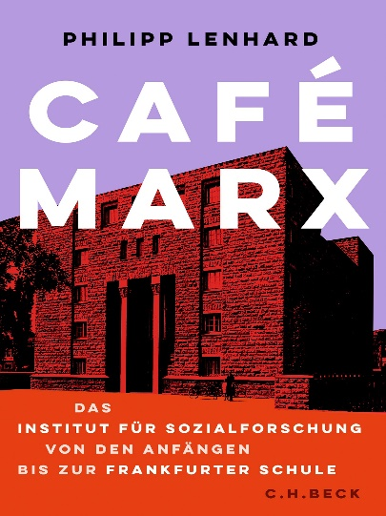

Café Marx: The Institute for Social Research from its Beginnings to the “Frankfurt School”
By Philipp Lenhard
624 pages, 6 illustrations, publication date: 14th March

Café Marx: this was the nickname given by both its friends and its enemies to the Institute for Social Research. And indeed, critical theory and the Frankfurt School have their origins in an engagement with Marxism. Drawing on a wide range of sources, Philipp Lenhard tells the story of the people, networks, ideas and places that shaped the Institute and were shaped by it in turn.
The history of the Institute for Social Research with its leading theorists Theodor W. Adorno, Max Horkheimer, Herbert Marcuse, Walter Benjamin, Franz Neumann and Leo Löwenthal is fundamental to understanding the German, European and American intellectual history of the 20th century. It encompasses both Jewish and political history, the history of ideas and the humanities, the history of emigration and the Holocaust as well as that of post-war reconstruction. It does not begin with the formal founding of the Institute between 1922 and 1924, but goes back to the time of the European catastrophe, starting on the battlefields of the First World War and the revolutionary upheavals that were to prevent such mass slaughter in the future. The emergence of the Institute for Social Research is also rooted in the bloodbath of the world war, the collapse of the German Empire and the attempts to radically reshape social life after the devastation of war.
Its foundation was a reaction to the failure of the revolution. Max Horkheimer and his colleagues recognized early on how fragile the Weimar Republic was, which had emerged from the November Revolution in 1918. And the Soviet experiment in Russia, which had been viewed with hope and sympathy for a long time – perhaps too long – disavowed itself with every new wave of terror and persecution. Even the Soviet Union, as the Institute’s staff understood in the end, was no alternative. On the contrary, Stalin’s despotism was a terrifying example of what could be made of Marxian theory when it was put at the service of domination and oppression. Critical Theory, which emerged in the following decades at the Institute for Social Research in opposition to both bourgeois liberalism and orthodox Marxism, was therefore, much to the chagrin of many communists, less revolutionary theory than a reflection on the failure of Enlightenment historical optimism.
In Philipp Lenhard’s new and innovative history of the Institute for Social Research, based on a broad range of sources from archives in Europe and the US, “the Institute” is explored from four perspectives: Firstly, the Institute was a concrete building in a specific location with particular architectural and material characteristics. Secondly, it was a meeting place for academics, students, Marxist activists, librarians and administrative staff. Thirdly, it was a research institution that was contractually integrated into the respective scientific landscape and organizationally supported by an independent association and a foundation. And fourthly, last but not least, it was a constantly changing idea over the course of its existence, and its employees put themselves at its service.
This differentiation makes it clear that this book, unlike its predecessors, is neither a collective biography nor a pure history of ideas. It is also not geared towards individual persons, but actually focuses on “the Institute” in all four of the aforementioned meanings. It goes without saying that individual personalities, works and ideas are also discussed. However, the methodological approach is different: on the one hand, this book traces the physical and symbolic spaces in which the Institute materialized, and on the other, it reconstructs the changing personal and institutional networks associated with these spaces. To put it simply: where was “the Institute” and what actually happened there?
In this spatial and network-historical narrative, it is above all constellations that come into view. Like stars, people, ideas and objects orbit around a center, are sometimes torn from their orbit and catapulted into the maelstrom of a new center. The further we look away from the individual planets and their fixed stars, the more entire constellations become visible, and in the end the entire universe presents itself as an arrangement of celestial bodies. Constellations can only be read when viewed together, and so this book also brings together various people, spaces, processes, thoughts and actions to form constellations from which the history of the Institute for Social Research emerges. By capturing the individual elements as points in constellations, as Walter Benjamin wrote as early as 1925 in the epistemological preface to his book The Origins of the German Tragic Drama, “the phenomena are divided and saved at the same time”. Those who look at constellations also look at individual personalities without making them absolute.
Particular attention is paid to marginal figures who have received little attention in research to date, especially the women working at the institute. They include scholars such as Hilde Weiss and Gretel Adorno, librarians and archivists such as Rose Schlesinger, Clara Mackauer and Elisabeth Ehrenreich, office managers such as Juliette Favez, Alice Maier and Margot von Mendelssohn, as well as students such as Gisèle Freund, Angela Davis and Elisabeth Lenk. However, in contrast to previous research, this book sees the Institute as a living organism that includes not only great theorists and academics, but also cleaners, porters and janitors.
This book does not claim to cover all the people, philosophical works and historical anecdotes relating to the history of the Institute for Social Research. Rather, it stands alongside other accounts of this history, not least the standard works by Martin Jay, Rolf Wiggershaus and Helmut Dubiel. However, the emphasis is recognizably different: Although it was indisputably the close circle around the director of the Institute, Max Horkheimer, who had a major influence on the fate of the Institute since 1930 at the latest, the many employees, fellows, cooperation partners and administrative staff were not mere objects controlled by an authoritarian director, but had their own ideas and interests to which too little attention has been paid to date. This also means not reducing the Institute for Social Research to the person of Max Horkheimer (or, after 1945, Theodor W. Adorno), but understanding it as a lively place of exchange and conflict.

Philip Lenhard
Philipp Lenhard is Professor of History and German at the University of California, Berkeley. He has spent years researching this topic and has found lots of new sources. For the first time, the Jewish history of the Frankfurt School and the history of women at the Institute are presented. No scholar before has researched the exile of the Institute in Paris or Geneva in such detail. All these merits would lead one to expect more of an academic book - BUT the book is written in a most narrative style. Each chapter focuses on a place and begins with a revealing scene in that place. The book is academically more ambitious than books by Eilenberger or Bakewell, but like those books it has its own narrative verve.

